**Crime in Chicago and How to improve the strategy**

**Rafael Oltarz**

**1. Introduction**

**1.1. Background**

Crime in Chicago has been a vital issue in the city. The Chicago Police Department's Records office has been tracking them since the early 1900s. It is appreciated how the general crime rate in the city of Chicago is higher than that of the US average. The reasons why Chicago has higher numbers within the US remain unclear.

**1.2 Problem**

Data that might contribute to determining wich is the best locations to set police controls.

**1.3 Interest**  
The interest in this topic arises from the large number of crimes in the city and the difficulty that the police have to combat them.

**2. Data Acquisition and Cleaning**

**2.1 Data sources**

The data provides from an IBM course in csv format.

**2.2 Data Cleaning**  
Only a few rows had to be removed and had to be led with some missing values. Nothing alarming.

**3. Exploratory Data Analysis**

**4. Crime maps analysis**

**4.1 Theft Crime map**

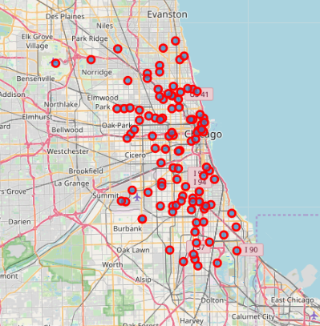

As the image shows, theft crime doesn’t follow a patter, it is randomly situated in the center of city street, then it might be nice to increase police patrol.

**4.3 Narco Crime map**

For narcotic crime cases, it mays follow a pattern in oak park and cicero zones for most cases, and such a few others in the south of main zone with some outliers. Maybe it could be good to install police controls in that area.

**4.3 Criminal Damage Crime Map**

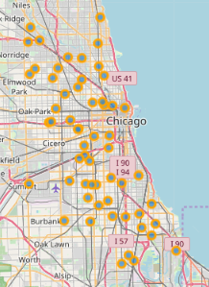

As the map shows, criminal damage crime is a crime highly randomly distributed as theft.

.

**5. Conlusions**

Throughout this presentation, it was demonstrated that the relevant crimes would be robbery and narcotics, among others. Each one has its best way of being prevented, but it is clear that acting on the affected areas and increasing the police presence in the city would be a good start as tools.